USE CASE DIAGRAM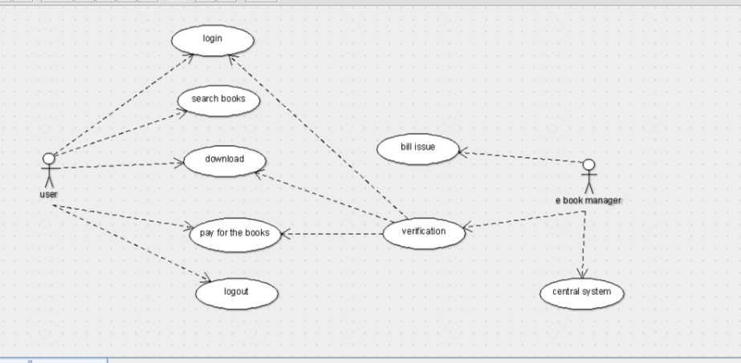

CLASS DIAGRAM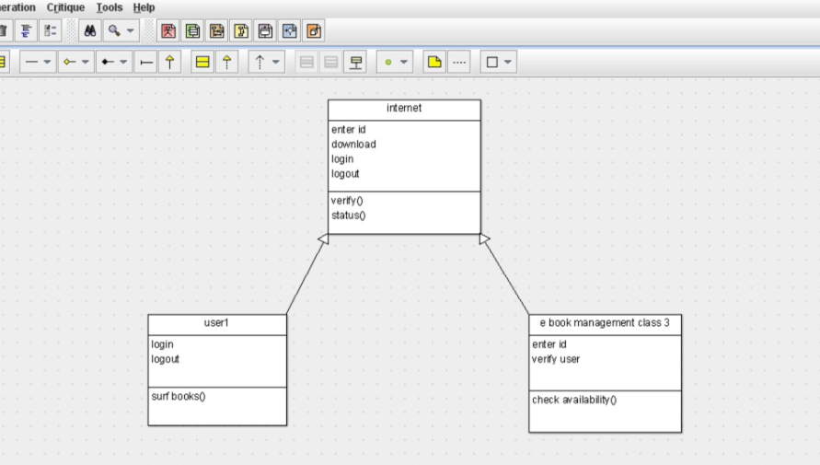

public class e book management class 3 extends internet {

public enter id;

public verify user;

public void check availability() {

}

}

public class user1 extends internet {

public login;

public logout;

public void surf books() {

}

}public class internet {

public enter id;

public download;

public login;

public logout;

public void verify() {

}

public void status() {

}

}

ACTIVITY DIAGRAM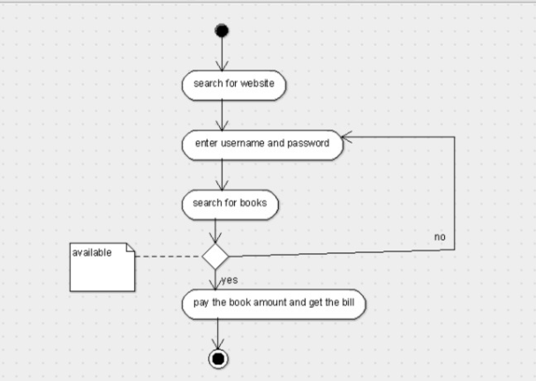

STATE CHART DIAGRAM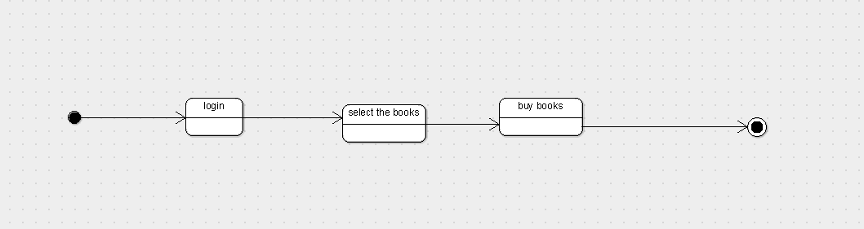

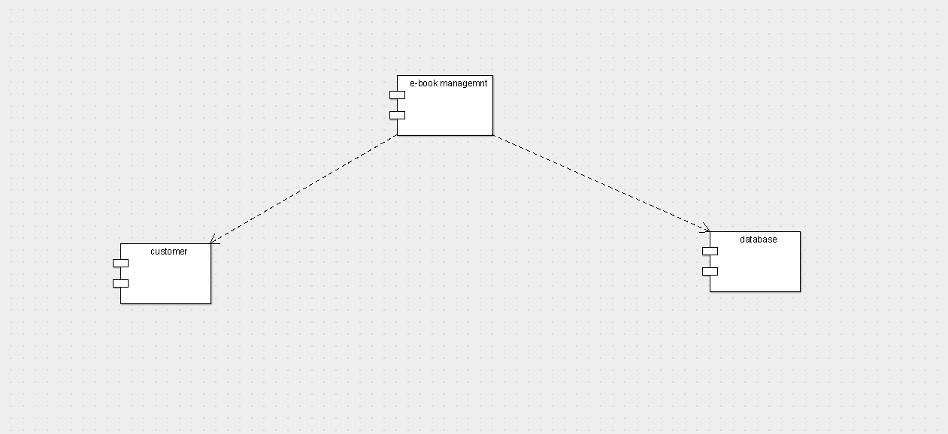COMPONENT DIAGRAM

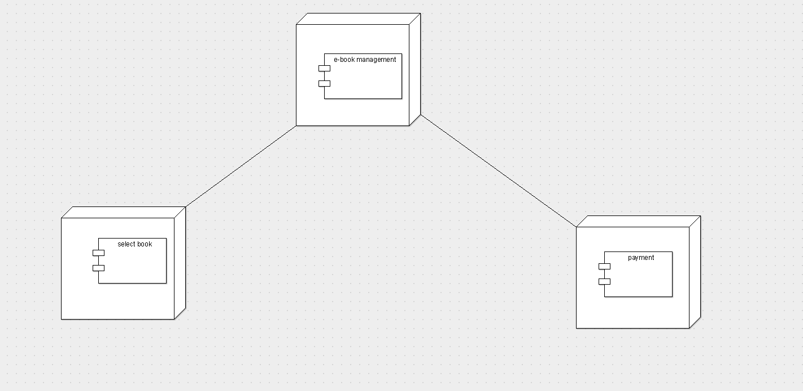

DEPLOYMENT DIAGRAM